Technical document
Contents
Technical document 1
Use of Hydrorock blocks for subsurface irrigation of orchards 1
Aim 1
Introduction 1
Hydraulic properties of Hydrorock material 1
Potential configurations 2
Evolution of soil moisture under two type of soils 5
Comparison of the performance of Hydrorock with a traditional irrigation system (bubblers) – pilot 6
Effects of Hydrorock irrigation on soil moisture levels 6
Effects of Hydrorock irrigation on date palm yield 7
Effects of Hydrorock irrigation on salt accumulation in the soil 7

Use of Hydrorock blocks for subsurface irrigation of orchards

Aim
This report provides a summary of the most relevant results obtained during the pilot test developed under the umbrella of the project “Advanced subsurface irrigation system using Hydrorock”, with the aim to develop a technical document for potential customers.
The results showed in the present report are still in a preliminary stage, since the pilot is still ongoing.

Introduction
This innovation is based on the technology developed by the Dutch company Hydrorock (HR), composed of sub-surface installed blocks made of mineral wool. So far, HR is using this technology for drainage, to reduce the risk of flooding. However, the technology can be also potentially used on the other way around, providing water to soil according to the crop water demand. Since the water is provided underground, and therefore close to the roots, no losses from direct evaporation or deep percolation are expected, increasing the efficiency of the system when compare with other traditional or modern irrigation technologies.

Hydraulic properties of Hydrorock material
Hydrorock material is mainly composed by mineral wool, a rock-based mineral material made into matted fibre, that can be used in several applications, such as thermal insulation, filtration or soundproofing. Thanks to its water related properties, this material can be also used for other water related applications, such as drainage, soilless medium culture or subsurface irrigation
The Hydrorock material presents the following water related properties (Table 1):
Table 1. Water related properties of Hydrorock material
Volumetric water content at saturation (cm³/cm³) | Dry Bulk Density (g/cm³) | Ks (cm/d)
0.92 | 0.12 | 750

- A very high capacity to store water under saturated conditions, with values of around 92%, meaning that the material is able to storage a lot of water per unit of volume.
- A very low dry bulk density compared with other soil media, with values of around 0.12 g per cm³.
- A very high saturated hydraulic conductivity (Ks) of around 750 cm/d, meaning that this material has a high capacity to transmit water under saturated conditions.
In Figure 1, a comparison of the water retention curve and the hydraulic conductivity between HR blocks and sandy soil can be found.
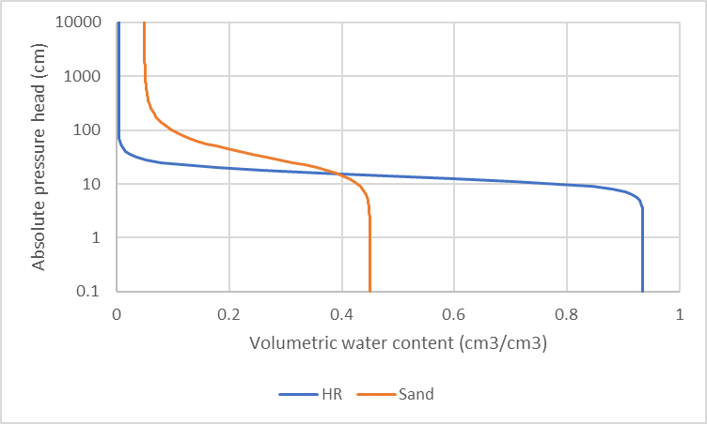 | 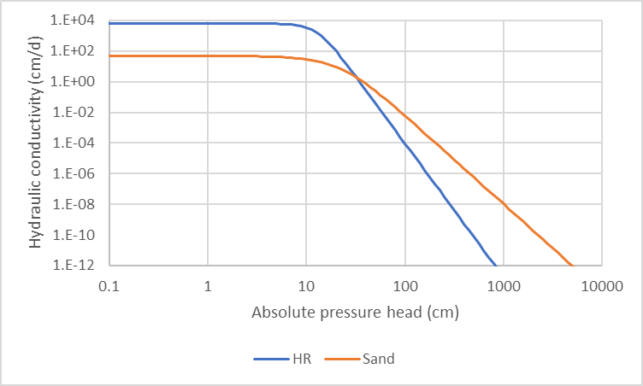
Figure 1. Comparison of (left) water retention curves and (right) hydraulic conductivity curves for HydroRock (HR) and sandy soil (example for Dubai)

Potential configurations
Hydrorock can be acquired in multiple configurations, according to the needs of the client. Hydrorock blocks are mainly recommended for subsurface irrigation or orchards, either for a completely new irrigation layout or as individuals elements to be connected to the existing irrigation system (plug & play). Hydrorock block can be acquired in different sizes and volume, according to the type of crop, water requirement or the capacity of the existing irrigation system, if any (Table 2).
Table 1. Hydrock blocks configuration
Product code | Description | Total volume (L) | Dimensions (cm) | Weight (Kg) | Water Content (L)
D20 IR irrigation unit | bottom and one lateral sealed with horizontal fibers for horizontal water release | 20 | 50x20x20 | 1.7 | 19
D40 IR irrigation unit | bottom and one lateral sealed sealed with horizontal fibers for horizontal water release | 40 | 100x20x20 | 3.4 | 38
D45 IR irrigation unit | bottom and one lateral sealed sealed with horizontal fibers for horizontal water release | 45 | 120x20x20 | 3.6 | 42.75
D112 IR irrigation unit | bottom and one lateral sealed sealed with integrated perforated drainage pipe 100mm | 112 | 120x30x3 | 9 | 106.4
Hydrorock blocks can be installed in line or in parallel to the piping network and the number of elements per tree can be calculated according to the irrigation requirements. The size and number of blocks per tree should at least allow to apply the water demand of 1 day of irrigation during the peak season (Figure 2). It is important to note that the Hydrorock blocks are sealed, with only one lateral and the top of the block unsealed. When the blocks are placed underground, the unsealed lateral should be placed against the tree.
The pipe can be connected by two ways:
- Connecting the open end of pipe to the top of the block by introducing the end of pipe between the stone wool and the protective geotextile membrane. This is mainly recommended for D20, D40 and D45 block and for an “in parallel” configuration
- Connecting the blocks trough a 100 mm pipe, by introducing the pipe in the integrated perforated drainage pipe. This is mainly recommended for D112 block and for an “in line” configuration
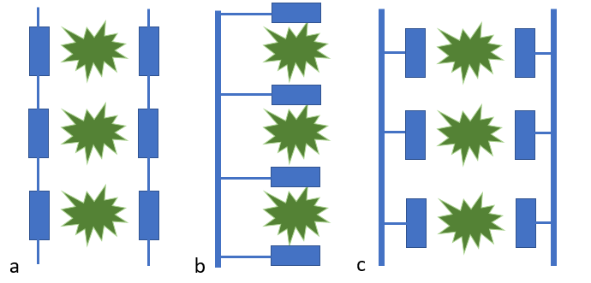
Figure 2. Different configuration option: a) in line with two elements per tree and blocks connected to a lateral pipe; b) in parallel, with two elements per tree and directly connected to a main/secondary pipe; c) in parallel, with two elements per tree and connected to lateral pipe
The Hydrorock blocks can be also part of a more integrated irrigation system, allowing the users to monitor in real time the soil moisture content, the water applied and the weather forecast (Figure 3). Those system can be also design to automatise the irrigation scheduling, according to a set of predefined conditions.
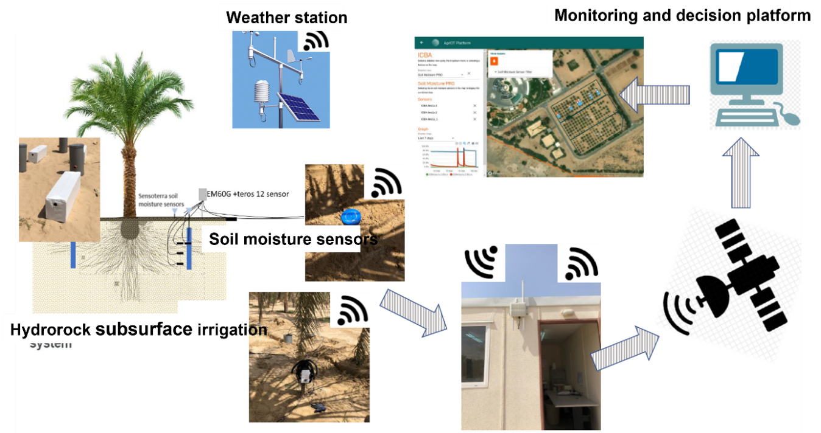
Figure 3. Potential layout of an operational irrigation system with HR blocks in a date palm plantation
How the water is delivered from Hydrorock blocks?
The functioning of the Hydrorock blocks is very simple. The water is applied to the block through an irrigation pipe and the block will be filled in few minutes, depending of the size/volume of the block and the flow of water. Once the Hydrorock element is filled, the water is delivered into the soil gradually through the non-sealed lateral, according the type of soil, wet conditions and the suction capacity of the roots (Figure 4). It is important to place the unsealed lateral against the tree, to favour root water uptake.
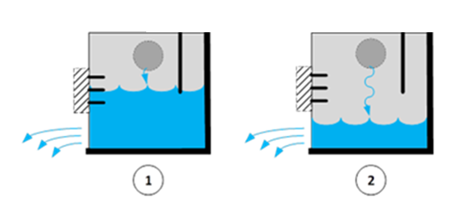
Figure 4. Schematisation of the functioning of a Hydrorock block
Due to the hydraulic properties of Hydrorock blocks, water is delivered gradually into the soil, but this will depends mainly on the soil type (texture) and wet conditions. In Figure 5, a simulation of the water flows between the Hydrorock block and the soil with the influence of a date palm tree is showed. After 2 days, most of the water is released into the soil and available for the roots (Figure 5). Five days later, no water is available.
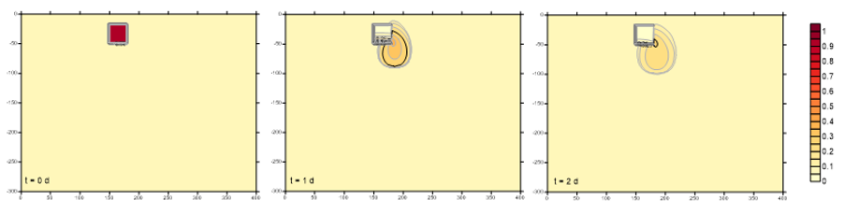
Figure 5. Simulation of an irrigation event on a sandy soil.
As can be shown in figure 6, the block is filled with water very quickly, reaching almost the maximum volume (90%) in few minutes. Due to the soil properties (sandy soil) and surrounding conditions (very dry), the water goes to the soil in few hours. Most of the water remains between 30-60 cm depth, while some water goes down by gravity, but still available for the roots. The steep increase in water content is due to the quick release of water by the Hydrorock element, since the surrounding sandy soil is very dry.
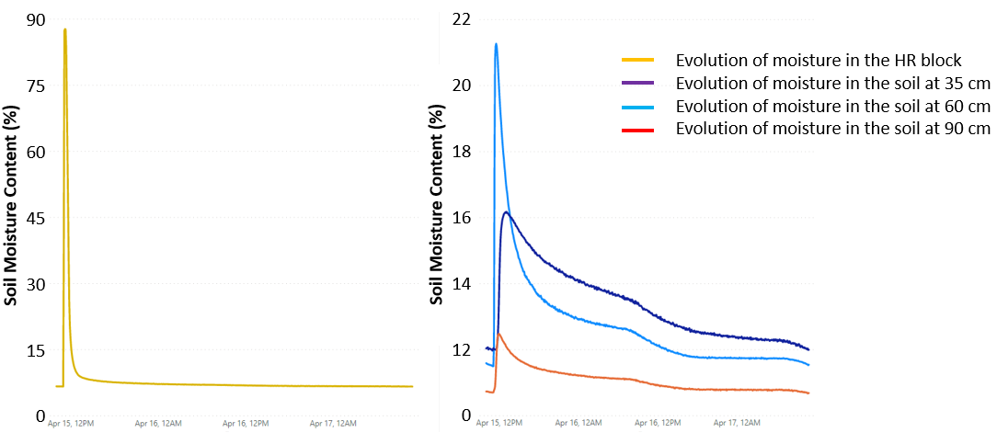
Figure 6. Evolution of water content in a Hydrorock element (left) and in the soil at 35 cm, 60 cm and 90 cm depth (left) on a sandy soil in arid climate, 72 h after irrigation.

Evolution of soil moisture under two type of soils
Soil properties and wet conditions influence highly how water move from the Hydrorock blocks into the soil. While in light soils (sandy) the water will move very fast in to the soil, especially in dry areas, in more heavy soils (loamy) the water will be released more gradually.
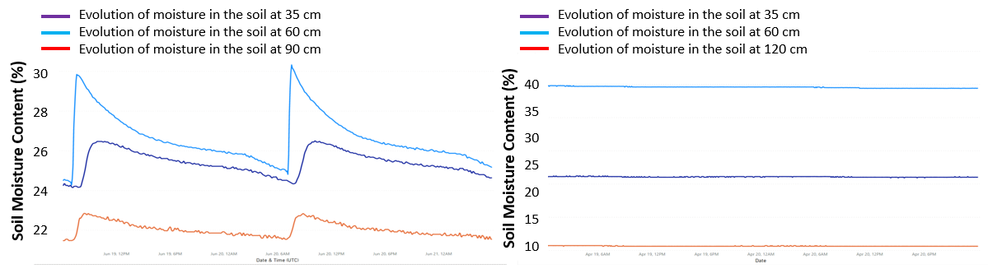
Figure 7. Soil moisture behavior over 48 hours in the Hydrorock system (soil), at 30,60,90 cm depths for a sandy soil (left) and a loamy soil (right).

Comparison of the performance of Hydrorock with a traditional irrigation system (bubblers) – pilot
In order to determine the performance of the Hydrorock system and compare it with other traditional irrigation systems (such as bubblers), a pilots was carried out at the International Center for Biosaline Agriculture (ICBA) located in Dubai. The pilot, conducted for 1 year (March 2021 to Feb 2022), consists on a date palm plantation irrigated with Hydrorock D112IR, placed at 30 cm depth. As a control, a bubbler system was also monitored. A total of 18 trees was irrigated per line of the experiment. Three types of water salinity levels was applied to investigate also the effects on salt accumulation.
Water was applied according to the ETc values, considering that in case of Hydrorock, there is no direct evaporation. In case of bubblers, the same estimation methos was used, including a leaching factor. From February 2021 to February 2022, the following total amounts of water (in m³) were applied to the Hydrorock and Bubbler lines.
Table 3 Water applied for different systems and salinity levels (ICBA, 2022)
Reference evapotranspiration, ETc (L/tree) | Hydrorock  (L/tree) | Bubbler  (L/tree)
1,168 | 1,347 | 2,277
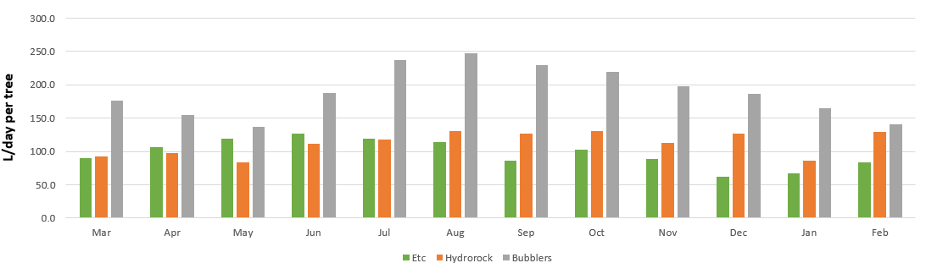
Figure 8. ETc versus irrigation applied (L/tree/day) data from March 2021 to Feb 2022.

Effects of Hydrorock irrigation on soil moisture levels
The total amount of water applied to Hydrorock was slightly higher than the Etc values, in order to wash some of the salts accumulated in the soil. The water applied to the Hydrorock was almost 40% less than the water applied to the bubblers.
However, since the water with Hydrorock us directly applied into the subsoil and therefore no subjected to direct evaporation on the top-layer levels, the soil moisture levels between both systems remains very similar (Figure 9).
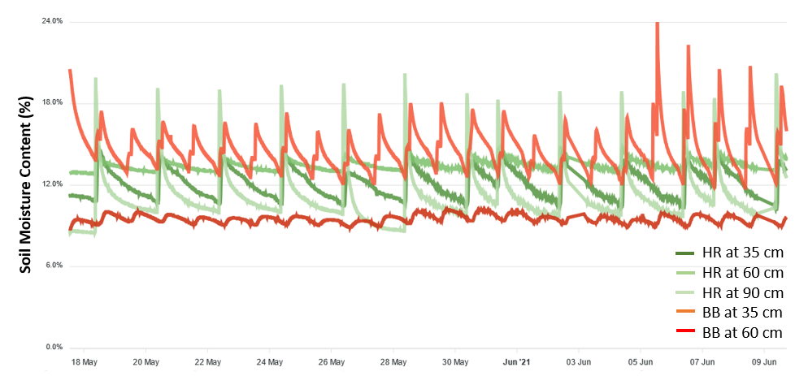
Figure 9. Evolution of soil moisture at different soil depths for a date palm line irrigated with Hydrorock block (green lines) and a date palm line irrigated with bubblers (red lines). Data showed from 18 May 2022 to 10 June 2022.

Effects of Hydrorock irrigation on date palm yield
Although the volume of water applied with Hydrorock was significantly lower than the one applied with the bubblers, no significant different were found in yields, with almost the same value for both treatments (Figure 10).
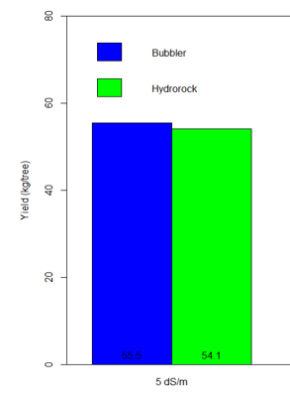
Figure 10. Fresh fruit yield of date palm irrigated with Hydrorock (green) and with bubblers (blue).

Effects of Hydrorock irrigation on salt accumulation in the soil
To compare the effect of Hydrorock elements on salt accumulation in the soil, a soil analysis was carried out by ICBA in 2021. Figure 11 shows higher salt build-up at medium and high salinity levels at all depths (especially in the topsoil). This may be because the amount of water applied through the HR system is sufficient to meet the crop water demand and does not provide any leaching. The situation is more difficult under higher salinity levels as the increase in salinity is much higher than the bubbler method. This situation can threaten the sustainability of crop production under the HR system.
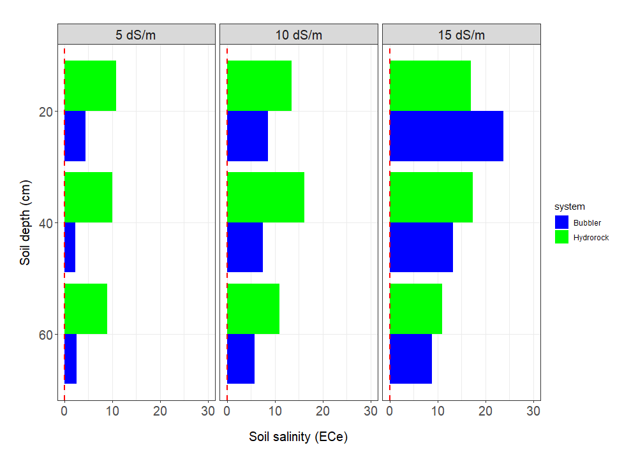
Figure 11 Soil salinity for bubbler and Hydrorock systems at three soil depths in Sept 2021 (ICBA, 2021)

These properties were measured in the Soil Hydro-Physics Laboratory of Wageningen University and Research, by the following methods: an adaptation of the "constant head method" (NEN5789/1991) for Ks; ISO 11272:2017 for the dry bulk density and volumetric water content at saturation.
For Hydrorock, k the water retention curve was digitized and fitted to van Genuchten from a whitepaper by Lapinus Rockwool (2018)
Simulation done using the FUSSIM2-own root water uptake models
Data monitored with Teros12 sensors on a real conditions plantation of date palms in Dubai (ICBA facilities). Blocks used Hydrorock D112IR, placed at 30 cm depth.

